Sanjay Desai MD FACP
Ventilator Wave Forms Oct 2014

Questions:

Case A: AC VC 60%; TV 500; R 20; PEEP 5; Decelerating 70 lpm; F trigger 3.
1 | Normal or Artifact
2 | Autopeep
3 | Ineffective Triggering
4 | Flow or Volume Starvation
5 | Other Problems
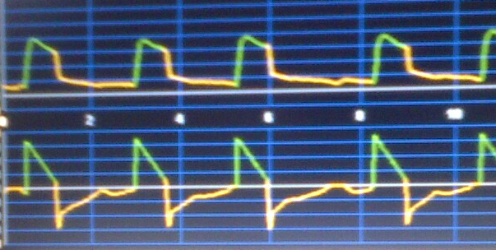
What are the problems?

What are the best next steps?

Case B: AC VC. Patient appears agitated.
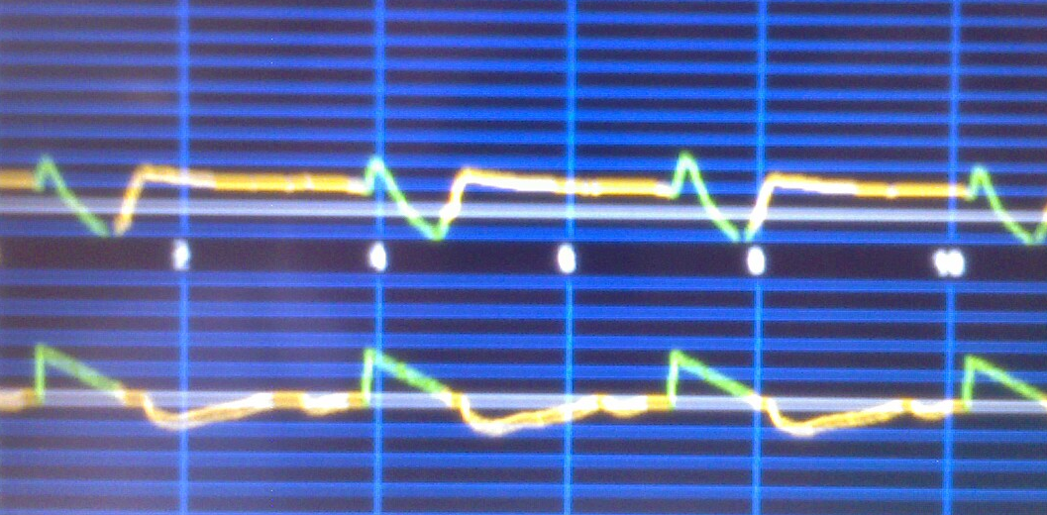
1 | Normal or Artifact
2 | Autopeep
3 | Ineffective Triggering
4 | Flow or Volume Starvation
5 | Other Problems
What are the problems?

ANSWERS:

Case A: AC VC 60%; TV 500; R 20; PEEP 5; Decelerating 70 lpm; F trigger 3.
1 | Normal or Artifact
2 | Autopeep
3 | Ineffective Triggering
4 | Flow or Volume Starvation
5 | Other Problems
What are the problems?

Case B: AC VC. Patient appears agitated.
1 | Normal or Artifact
2 | Autopeep
3 | Ineffective Triggering
4 | Flow or Volume Starvation
5 | Other Problems
What are the problems?

